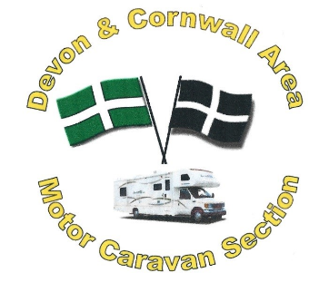
Motor Caravan Section
62nd National Meet & AGM
Haynes Motor Museum.
Sparkford Yeovil
Somerset BA22 7LH.
All units Welcome to join us.
Friday 24th -Tuesday 28th May 2024
Just follow the signs for Fleet Air Arm Museum from the M5 to A358 and on to A303 and pick up signs for Haynes Motor Museum.
Friday: sign in and enjoy a cup of tea/coffee and a chat with old & New friends. No need to cook a Fish & Chip van will be on site. Come and enjoy the music and dancing in the evening in the Merlin Suite.
Saturday: free and easy. In the evening come and enjoy the music.
Sunday: AGM and later enjoy a Picnic in the field so bring a drink and some food and listen Stoke-sub-Hamdon Brass Band. In the Evening entertainment by Jonathan Marks and the Raffle.
Monday: Coach trip to Bath or free and easy day. Evening entertainment

After Meet- Topsham RFC Tuesday 28th May - Sunday 2nd June 2024
more information, please see web site www.devonandcornwallmcs.com.

62nd National Meet & A.G.M

Membership number__________________ 4 Nights Friday – Tuesday £95.00 £________
Name _______________________________ 4 Night Single OCC £ 85.00 £ _________
Address____________________________ Extra Adults £30.00 £__________
___________________________________ PENNANT £6.50 £_________
Post code __________________________ COACH TRIP per person £14.00 £__________
Telephone number____________________ TOTAL COST £__________
Unit ___________Reg Number _________
Area / DA_________________________ Disabled Area__________
No Adults___________ No Children________
A unit consists of Max of 2 Adults plus children.
I enclose cheque made payable to Devon and Cornwall MCS___________
Or Paying Bacs ______sort code 56-00-63 account no 43635202 ref HM & your membership no
ALL BOOKING FORMS MUST BE POSTED WITH A5 S.A.E FOR RETURN INFORMATION
TO June Pope 49 Bubwith Rd Chard Somerset TA20 2BP.
Tel 07875 322059 please call after 3.00pm weekdays.
Web Dec 2023

